- Open SAM

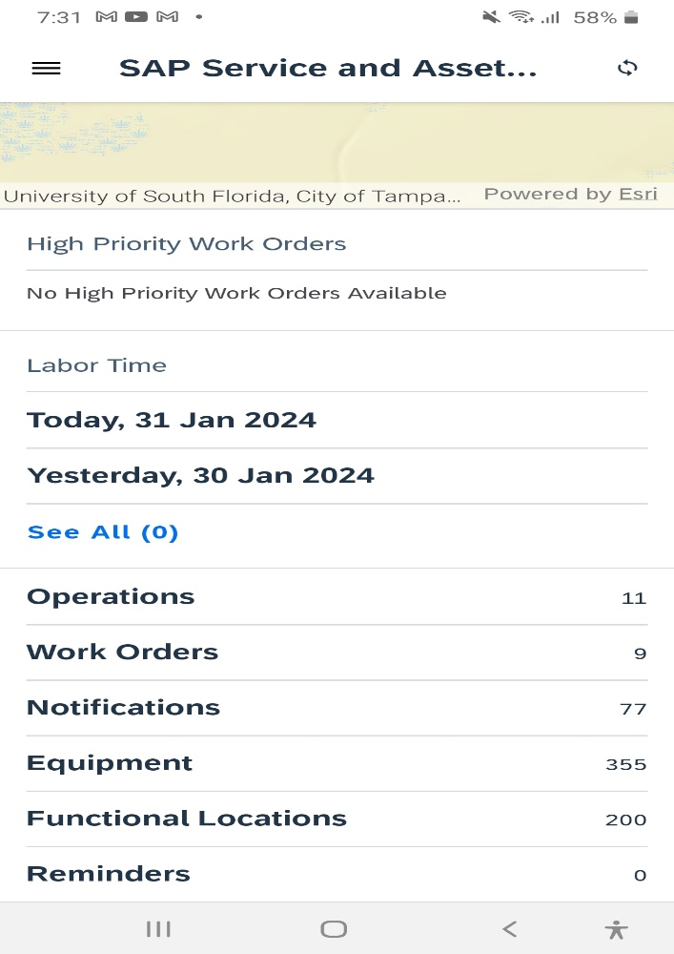

- Go to Functional Locations

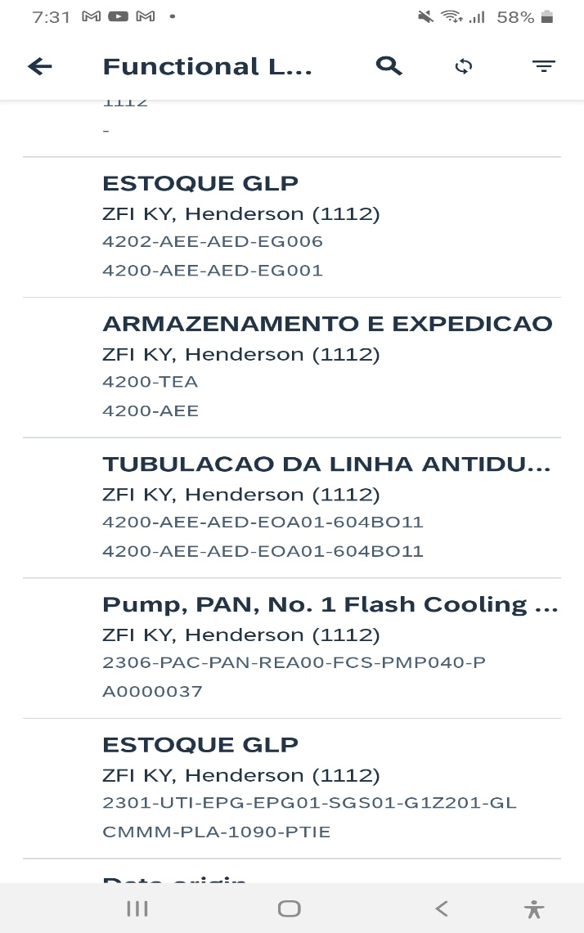

- Search with Sort Field “A0000037”.

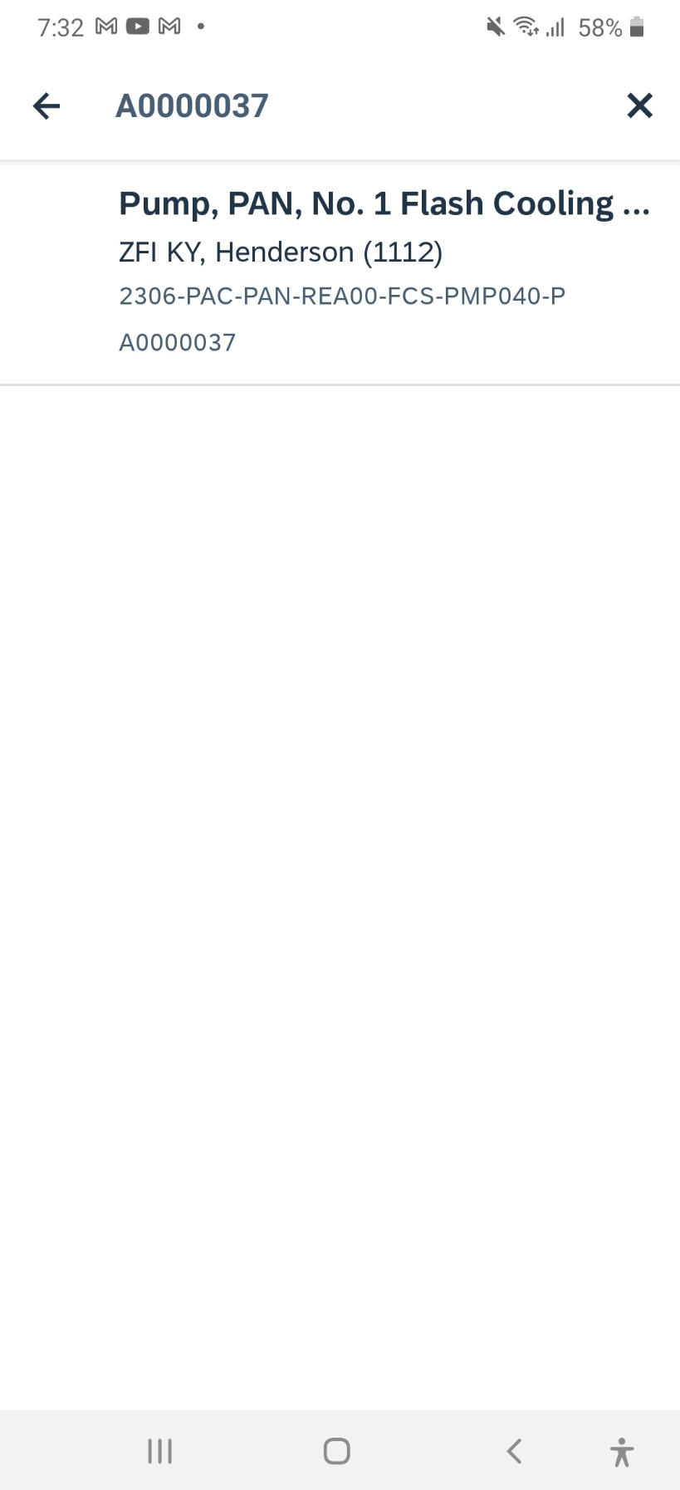

- You will find functional location with sort Field “A0000037”
TEST RESULTS: PASS

